**Midterm Point of Sales Group 1**

1. **Requirements**

**Invoice Management Flow**

* **Create New Invoice:**
  1. User selects a customer.
  2. User adds products to the invoice, specifying quantities.
  3. System validates the products (must be configured and active).
  4. System calculates the total invoice amount.
  5. Invoice is saved with a unique ID, and timestamps for creation and update.
* **Edit Invoice:**
  1. User selects an existing invoice (within 10 minutes of creation).
  2. User modifies invoice details or products.
  3. System re-validates the products and recalculates the total amount.
  4. Updated invoice is saved with a new update timestamp.
* **View Invoice:**
  1. User requests invoice details.
  2. System fetches and displays customer details, invoice details, and product list.

**Product Management Flow**

* **Add/Edit Product:**
  1. User provides product details (name, price, status).
  2. System validates the input data.
  3. Product is saved with unique ID and timestamps.
* **Activate/Deactivate Product:**
  1. User requests to change product status.
  2. System updates the product status accordingly.
* **Import Products:**
  1. User uploads an Excel file with product details.
  2. System reads and validates the file.
  3. Products are saved in the database.

**Customer Management Flow**

* **Add/Edit Customer:**
  1. User provides customer details (name, phone number).
  2. System validates the input data.
  3. Customer is saved with unique ID and timestamps.
* **Activate/Deactivate Customer:**
  1. User requests to change customer status.
  2. System updates the customer status accordingly.

1. **Database Design**

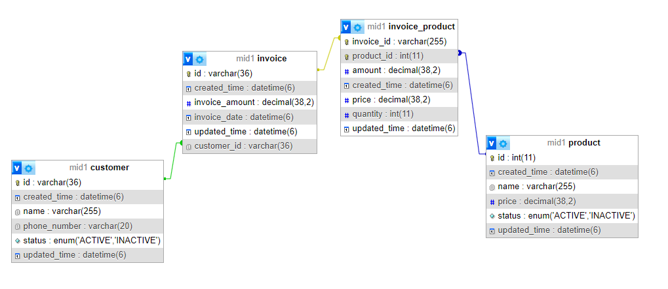

1. Bussinees Diagram Invoice Management

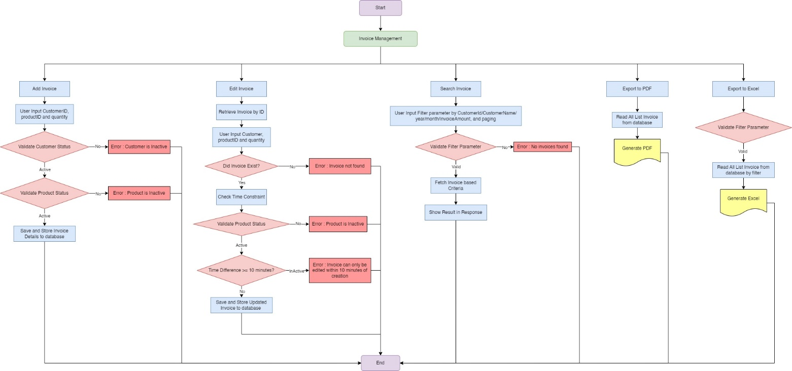

1. **List API**

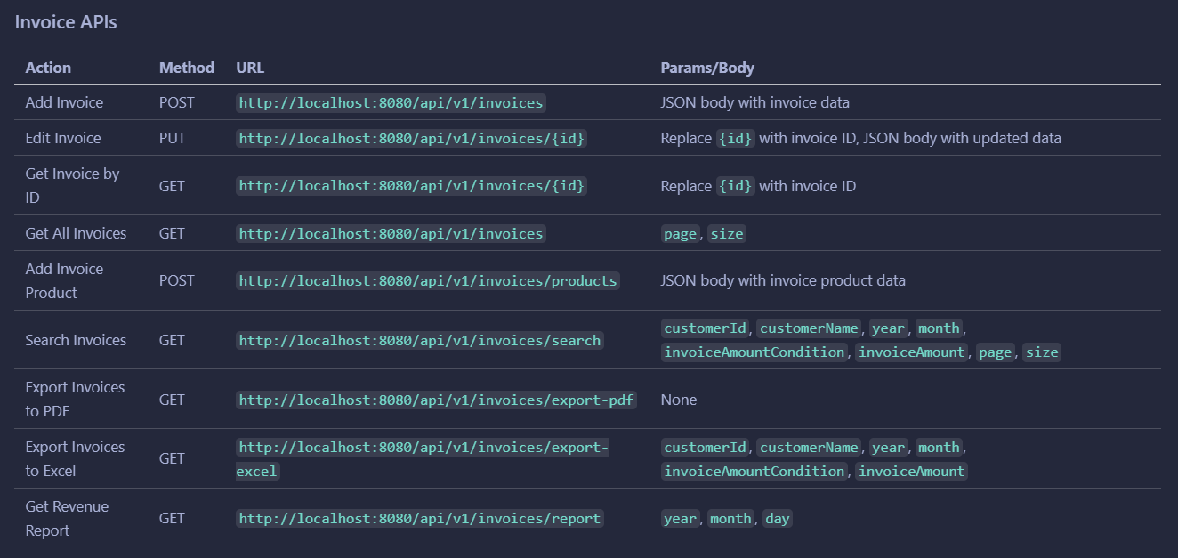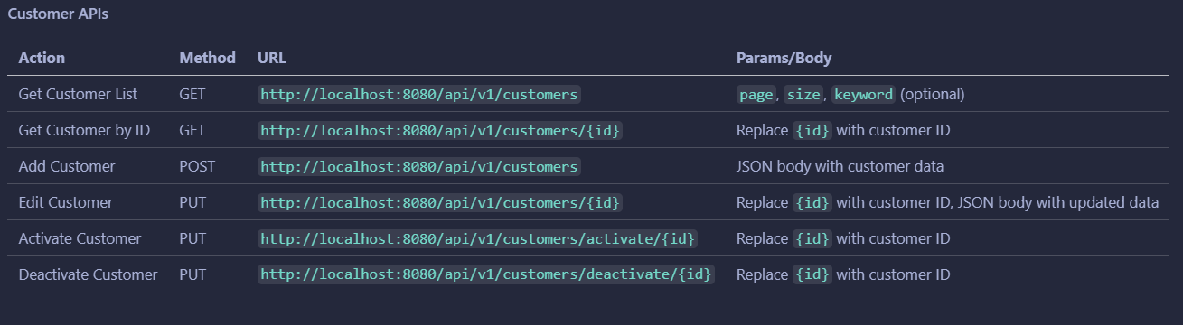

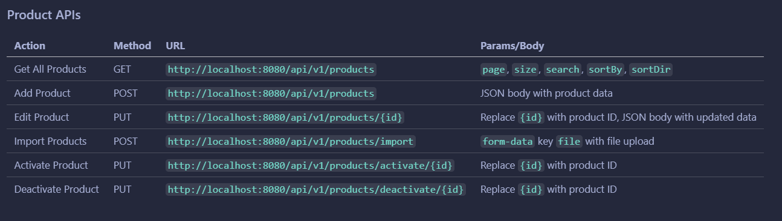

1. **API Documentation**
2. Add Customer

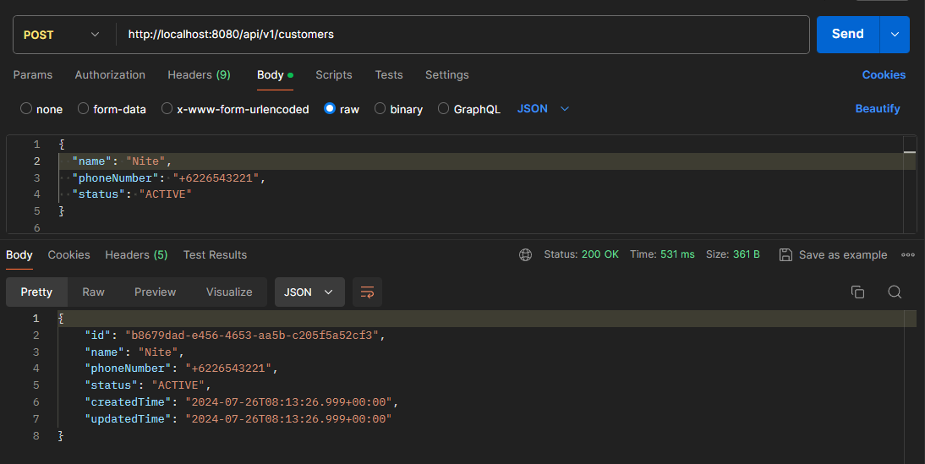

1. Activate Customer

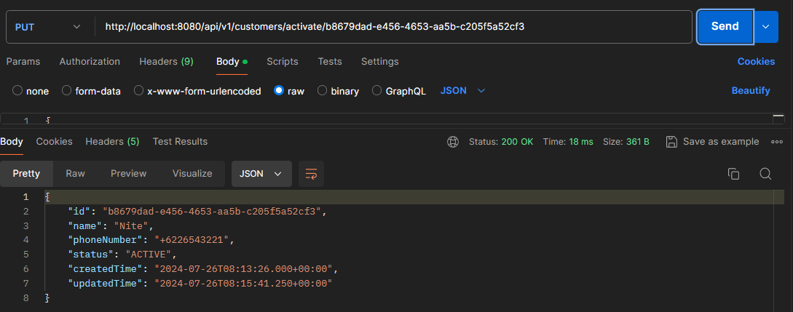

1. Deactive Customer

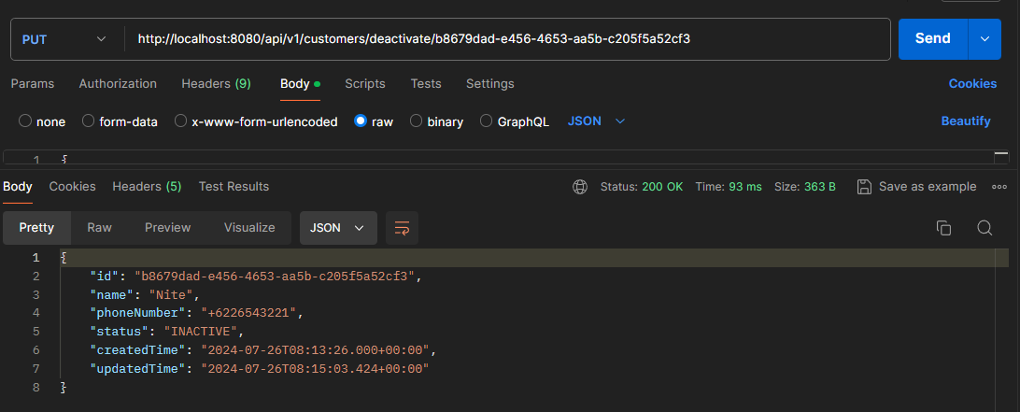

1. Paging and Search Customer by name

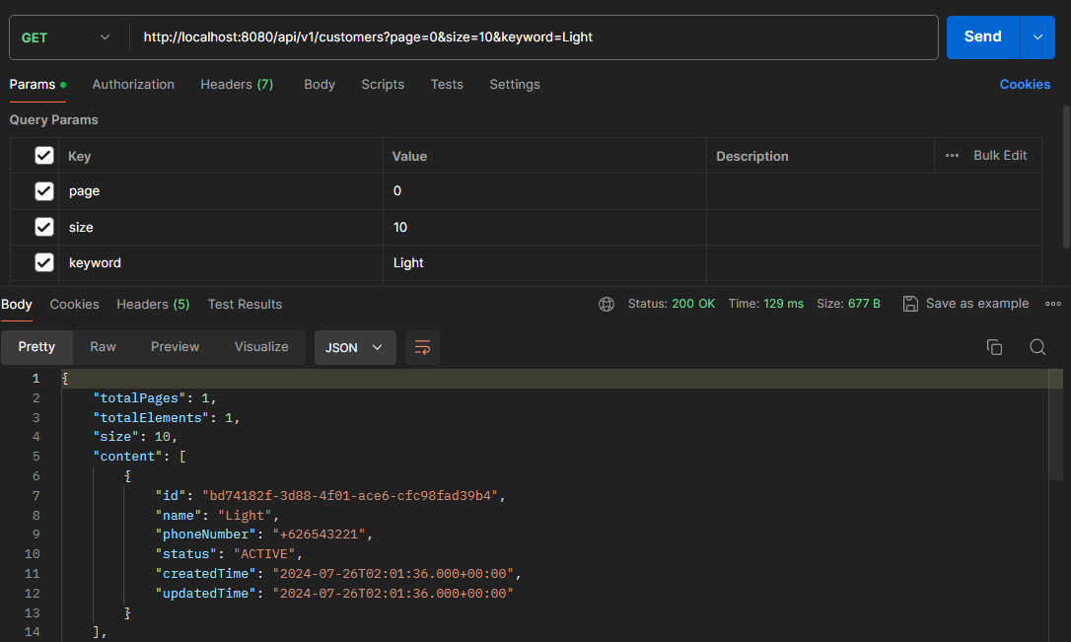

1. Upload Product from file

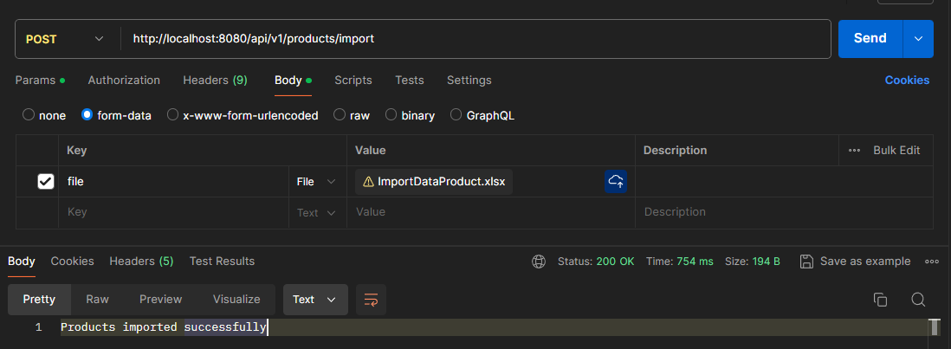

1. Add Customer and Multiple Product to Invoice

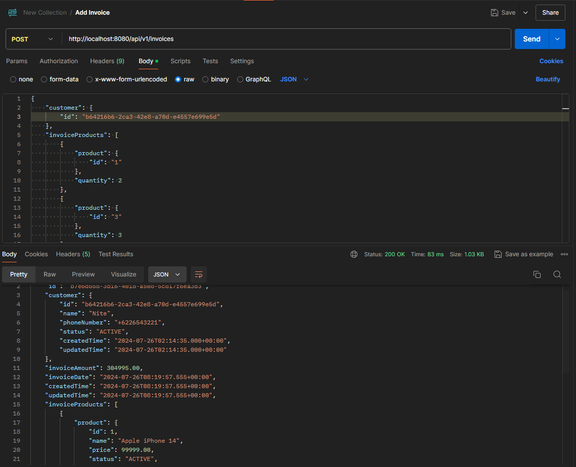

1. Export all Invoice details to pdf

